**<Reactive LED matrix>:  Team 27**

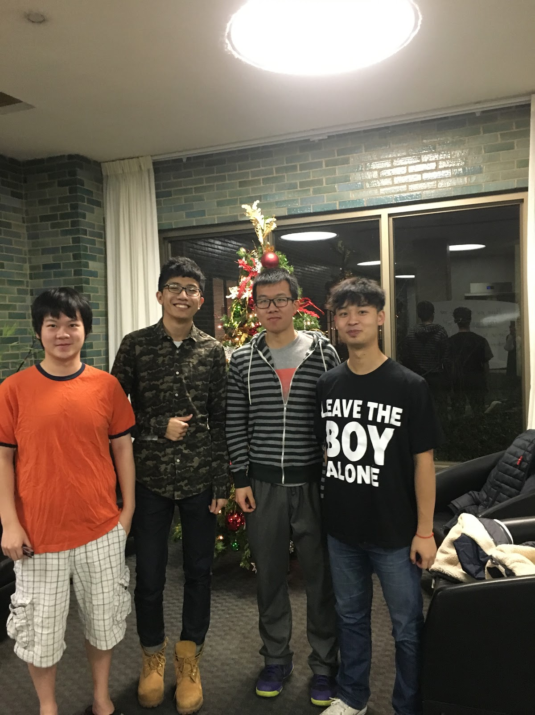

|  |  |  |  |  |
| --- | --- | --- | --- | --- |
| *Team Members (left-to-right on picture, above)* | *Class No.* | | *Lab Div* | |
| Xiaoyuan Zhang | 6441-Z | | 6 | |
| Mengshi Feng | 7092-F | | 10 | |
| Junyan Shi | 5224-S | | 6 | |
| Zhuofan Li | 2066-L | | 10 | |
| *Report/Functionality Grading Criteria* | | *Points* | |
| Originality, creativity, level of project difficulty | | 20 | |
| Technical content, succinctness of report | | 10 | |
| Writing style, professionalism, references/citations | | 10 | |
| Project functionality demonstration | | 20 | |
| Overall quality/integration of finished product | | 10 | |
| Effective utilization of microcontroller resources | | 10 | |
| Significance of individual contributions* | | 20 | |
| *Bonus Credit Opportunities* | | *Bonus* | |
| Early completion | | 0.5% | |
| PCB for interface logic | | 2% | |
| Poster (required for Design Showcase participation) | | 1% | |
| Demo video (required for Design Showcase participation) | | 1% | |
| Design Showcase participation (attendance required)* | | 1% | |

**\****scores assigned to individual team members may vary*

|  |  |
| --- | --- |
| *Grading Rubric for all Criteria (Including Bonus)* | *Multiplier* |
| *Excellent* – among the very best projects/reports completed this semester | 1.0 - 1.1 |
| *Good* – all requirements were amply satisfied | 0.8 - 0.9 |
| *Average* – some areas for improvement, but all basic requirements were satisfied | 0.6 - 0.7 |
| *Below average* – some basic requirements were not satisfied | 0.4 - 0.5 |
| *Poor* – very few of the project requirements were satisfied | 0.1 - 0.3 |

**TABLE OF CONTENTS**

|  |  |
| --- | --- |
| 1.0   Introduction | 4 |
| 2.0   Interface Design | 6 |
| 3.0   Peripheral Utilization | 8 |
| 4.0   Software Narrative | 9 |
| 5.0   Packaging Design | 11 |
| 6.0   Summary and Conclusions | 12 |
| 7.0   References | 13 |
| Appendix A:  Individual Contributions and Activity Logs | 14 |
| Appendix B:  Interface Schematic and PCB Layout Design | 25 |
| Appendix C:  Software Flowcharts | 26 |
| Appendix D:  Packaging Design | 28 |

**1.0**         **Introduction**

This project is an implementation of LED matrix that is reactive to object motion using MC9S12C32 (“9S12”) microcontroller. That is saying, when a nearby motion is being detected, the corresponding LED will turn on automatically, and turn off once the object is leaving the detectable area. Our LED matrix are pre-programmed and has four modes to make it more attractive and playable. User could toggle within four different modes by pushing the SPDT pushbutton, and the corresponding mode and its name will show up on the LCD display screen.  “Mode 1”, or “Magic Shift” mode maintain the function describe above, the LEDs will illuminate once object is being detected. “Mode two”, or so called “paint board” allows user to “draw” on the LED board. The LEDs will turn on as mode one when user’s motion detected, but they won’t turn of automatically even if there’s no object in sensing range. Additionally, user could erase what they drew as long as one board has been fully filled (all LEDs turned on). “Mode three”, or “A sky of stars”, has the same functional property as “Mode one”, but provides a fancier visual effect, where LEDs will blink twice before it turns off.

In our implementation, eight same-sized Protoboard with each has 32 LEDs and 8 pairs of IR sensor are used for LED matrix. Each board is controlled by an on-board microcontroller and functions as a self-contained, stand-alone device. Each pair of sensor, which could emit infrared light, detect nearby motion and generate analog outputs, controls four adjacent LEDs. In addition, a LCD display is used for informing user the mode name. The LCD display would change along with the actual play mode of LED matrix once pushbutton has been clicked. A 5V 1A voltage regulator is chosen to power our whole circuit, where all boards as well as the LCD are connected in parallel.

Although every member of the team worked on all aspects of the project, each member coordinated the completion of different tasks. The role of packaging leader was played by Junyan Shi, who took charge of debugging hardware, soldering protoboard, and final packaging. Zhuofan Li and Mengshi Feng shared interfacing leader role. Both of them worked together, designed the circuit, wiring alignments, purchasing all electronic and mechanical parts online and soldered most of boards. Video was demonstrated by Junyan Shi, Zhuofan Li, Mengshi Feng and made by Mengshi Feng. The poster was designed by Zhuofan Li. The role of peripheral and software leader was played by Xiaoyuan Zhang, who utilized our all four peripherals and software. Documentation are shared, with all contribute to specific portion of report.

**2.0**         **Interface Design**

Apart from MC9S12C32 microcontroller, 2 parts are included in our design.

Interactive LED board

A single board is controlled by a microcontroller individually, we have 8 pairs of IR emitters & detectors corresponding to 8 Analog inputs of the 9S12C. 220-Ohm resistor is in series with IR emitter and 10K-Ohm resister is in series with IR detector, these resistors were chosen carefully for the current limiting purpose according to Andrew Wilson [1]. However, 270-Ohm resistor is not available, so 220-Ohm resistor is replaced here. IR emitter & detector will detect the proximity of your hand’s motion, when your hand is closer, the output voltage will decrease, and vice versa. The threshold is set to 150 initially, but since 8 LED boards were connected together, in order to reduce the interaction within other LED boards, after several experiments, the threshold changed to 70.  A pair of 4 LEDs in parallel, surrounding the pair of IR emitters & detectors and 2 resistors, serve as the output, connected to Port T of the 9S12C. The turn on voltage of the LED is about 3.1 Volts, and each LED’s sourcing current is about 2.3 mA, so the total current is less than the 10mA (The maximum sourcing or sinking currents of Port T), we did not need to use resistors connected to LEDs.

Central Control part

A central microcontroller is used in the Central Control part, along with a pushbutton, a external Gal22v10 8-bit shift register and LCD screen. The pushbutton is wired to PM3 of 9S12C of all the LED boards, the purpose is to change the different display modes. A 5V-1A power supply is also connect to the central control part, and the power is shared by all the LED boards. Port pin PM4 (MOSI) in the 9S12C was connected to shift register’s data input. Port pin PM5 (SCK) serves the CLK of the shift register. The Port pin declaration could be found in ECE 362 website [2]. Finally LCD was interfaced to the 9S12C via the shift register.

**3.0**         **Microcontroller Resource Utilization**

In our mini-project, we have utilized the following microcontroller’s peripherals: ATD, SPI, TIM and RTI.

1. ATD

ATD is operated in normal mode. 8 infrared detectors are connected to the analog inputs of the microcontroller (AN0 ~ AN7) ATD converts the input analog voltage into 2-byte hexadecimal numbers (0x00~ 0xFF), when the value in the ATD data register is less than the threshold we set it indicates that the motion is detected.

1. SPI

SPI is used to realize the data transmission between the central microcontroller (master) and LCD screen (slave) via a 8-bit shift register. MOSI (PM4) and SCK (PM5) of the SPI module are utilized for the interface. LCD is interfaced to display the different modes and the corresponding mode names.

1. TIM

The Timer module is utilized to control the different display modes. In mode 3, the blinking mode, TIM is operated to realize the blinking of the LEDs. We wrote a recursive function cooperative with TIM to realize the blinking feature of each LED sets.

1. RTI

Real time interrupt is used to sample the push button to display in different modes.

**4.0**         **Software Narrative**

The software consists of 4 independent components that respectively control four different modes of the project. A single pushbutton would trigger the mode change with utilization of RTI to read the state of pushbutton every 131.02ms. A TIM module is also utilized to generate an 1ms interrupt, which would increment tenths-second-counter up to 10. The microcontroller waits before tenths-second-counter reaches 10 to operate its task designated by the mode number. At that time tenths-second-counter would be cleared to 0.

In mode 0 the microcontroller is in dormant state and would not respond to external stimulation. This is achieved by set up all the PTT pins connected as the output to the LED to logical low.

In mode 1 the microcontroller would turn on the LEDs closest to its detected objects. With the help of ATD, the result registers of the ATDs would be compared to a programmable threshold value and would turn on the corresponding PTT pins when these result values are less than the threshold value. The ATD is in program-driven mode.

In mode 2 the microcontroller is different than in mode 1 such that when objects approach the sensors, the LEDs would not respond, and maintain their current states until they are allowed to change their states. This functionality could be achieved by setting up a toggle variable to indicate the next state(on/off) LEDs would become if they are allowed to change their states. The toggle variable would toggle between 0 and 1 when all the LEDs are in the same states (on/off). When objects are nearby around the sensors, the ATD result registers would return voltage values lower than threshold, and at that moment, the program would check if the current states of affected LEDs by motion of nearby objects is different from the toggle variable. If it is different, it means the LEDs are in states that could be allowed to change and affected LEDs by motion of nearby objects are all changed to opposite states of the current states; if it is not different, it means the LEDs are not in states that could be allowed to charge and maintain their current states. For ATD that would not be affected by the motion of nearby, the ATD result registers would return voltage values higher than threshold and their corresponding LEDs also maintain their current states.

In mode 3 the microcontroller would blink on and off twice when it detects the objects around closest ATD. Each LED would operate independently, meaning that when one of LED is in the progress of blinking, the software can still detect closest objects around other ATDs. This software of this mode is the most demanding part in this software. It is achieved mainly by using recursive function. This part is also considerably different from previous parts such that the ATD operation is done in timer interrupt not in the main loop. This would fully utilize the function of interrupt, which asks the program to halt what is currently running in main loop and devote resources to taking care of demand in the interrupt. In the interrupt, the ATD would be used to detect the nearby objects, just like what ATD would do in other modes. When ATD detects objects, the result register would output a value below the threshold value.

**5.0**         **Packaging Design**

The packaging for this project was comprised of several stages: box design, space allocation, size calculation, design revision, decoration design and parts purchasing. Each of these phases was important to appearance and practicality for the project.

At the beginning, we had a group meeting and made a decision of using a box to hold our LED matrix. There were many considerations regarding what kind of box would be necessary for the functionality of the project as we intended. The first and the most important thing we need to consider is the size of the box, which can’t be too large, but needs to fit our LED matrix. We thought we could make a wooden box by cutting several wooden board and then glue them together. In this way, we can make a size that we want. However, the time constrains us to do so. Therefore, we did the second plan, which is to buy a box. our LED matrix’s size is 48 x 36 cm. And we also need to save a space for the central micro-controller, so we ordered a 61 x 51 x 3 cm hard paper box from the Amazon.

To initially adapt the box for the project, a decoration paper was used to cover the most part of our project. We measured the LCD and the pushbutton’s position according to the box.  Then we used a ruler and a cutter to cut a square for the LCD, and a hole puncher to dig a hole on our decoration paper for the pushbutton. In this way, we successfully hide wires and other parts which are not suitable for the exterior of the project.

Finally, we have a lid to cover the project for the project transport.

**6.0**         **Summary and Conclusions**

While we were doing this project, we experienced the whole process of implementing a project from concept generation to final packaging. We are now more confident to handle a project processing: importance of time management, the key to maintain team chemistry and division of labor. The overall teamwork strategy we used was collaborative-- we had very frequent team meeting and tended to solve problem together. This project was a great practice of the peripherals we learnt through all semester.  Also, this project brought us more solid hardware technique. From soldering, wiring realignment to power supply selection. These are brand new experience for our entire group.

The most pity part of our project was failing to use PCB. Initially, when we had the ideas about our project, we were trying to design 8 PCB for our interface since it could reduce our workload by a lot. On each board, there would be 32 LEDs, 8 pairs of IR emitters and detectors and 16 current-limiting  resistors in 8 pairs. All the parts mentioned above must be placed delicately for the performance. It seemed very hard to us without any previous PCB design experience. We cannot say for sure whether the PCB worked and there would not be enough time for a second try.  Thus we gave up designing PCB and decided to build it by soldering the protoboard by hands. We learnt how to optimize and design the wiring and circuit to make the work easier and more efficient.

We built a simple test environment on the breadboard so that we can working on our hardware circuit and test the functionality of the software simultaneously.

The most tricky part of our project was selection of device that supply’s the power of our project. One of the choice is using USB cable to supply the power, but it could not even drive two boards. Another is using the wall adapter power supply, we did not get many choices, we had only 5V-1A, 5V-0.8A and 9V-0.3A. We did not have many choices and we did not realize that would be a problem before. Fortunately 5V-1A worked well, which was able to drive our 9 microcontrollers, LCD, IR emitters & detectors and LEDs. If we were to do the project over again, we should definitely concern about the supplying power first.

With more time, we might try finishing PCB design so that our circuit wiring would be cleaner and fewer wiring issues. Also, we would definitely try using communication between our overall control microcontroller and sub-microcontroller of our eight parallel protoboard using SPI peripheral. In that way, the overall microcontroller could be able to control all eight board, and eight board could work as one whole, which would allow us program some mini game and even a sensing board that could be used as input equipment of other projects.

**7.0**         **References**

[1] Andrew Wilson. (1997-2006). Basic IR Detector/Emitter. Available:

<http://www.reconnsworld.com/ir_ultrasonic_basicirdetectemit.html>

[2] ECE 362 website. 9S12C Module Connections. Available : <https://engineering.purdue.edu/ece362/MiniPrj/PDF/module_connections.pdf>

[3] Motorola, Inc. (2003 January 25) MC9S12C Family Device User Guide.Available:<https://engineering.purdue.edu/ece362/Refs/9S12C_Refs/9S12C128DGV1.pdf>

**Appendix A:**

**Individual Contributions**

**and**

**Activity Logs**

**Activity Log for:**  Junyan Shi        **Role:** TDP (team, packaging leader)

|  |  |  |  |  |
| --- | --- | --- | --- | --- |
| ***Activity*** | ***Date*** | ***Start Time*** | ***End Time*** | ***Time Spent*** |
| Project proposal brainstorm | 11/13 | 6:00PM | 8:00PM | 2 hours |
| Project Initiate | 11/20 | 4:00PM | 6:00PM | 2 hours |
| Project role assignment | 11/21 | 3:00PM | 5:30PM | 2.5 hours |
| Asking professor about IR sensors | 11/23 | 1:00PM | 2:30PM | 1.5 hours |
| Ordering parts and finding the right pair of IR sensors | 11/23 | 4:00PM | 5:00PM | 1 hour |
| Parts comparison and purchasing | 11/24 | 2:00PM | 4:00PM | 2 hours |
| Eagle PCB tutorial learning | 11/25 | 9:00PM | 11:00PM | 2 hours |
| PCB wiring design but didn’t not get how to optimize the wiring | 11/26 | 10:00PM | 0:00 AM | 2 hours |
| Gave up PCB designing | 11/27 | 1:00 AM | 2:00 AM | 1 hour |
| Soldering first 3 boards including all the wires | 11/30 | 3:00 PM | 11:00PM | 8 hours |
| Soldering the 4th board | 12/1 | 5:00 PM | 8:00 PM | 3 hours |
| Soldering the 5th board and preparation | 12/4 | 7:00PM | 11:00PM | 4 hours |
| Finishing soldering the last 3 boards | 12/5 | 4:00PM | 9:00PM | 5 hours |
| Discussing the packaging and ordering the box for packaging | 12/6 | 4:00PM | 7:00PM | 3 hours |
| Connecting all the boards and testing | 12/8 | 5:00PM | 12:00PM | 7 hours |
| Integration testing, discussing about different power supply plans and packaging | 12/9 | 4:00PM | 5:00AM | 13 hours |
| Final preparation and demonstration | 12/10 | 3:00PM | 4:30PM | 1.5 hours |
| Video capturing and report writing | 12/10 | 7:00PM | 8:00AM | 13 hours |
| Spark Challenge design showcase | 12/11 | 2:00PM | 6:00PM | 4 hours |
|  |  |  |  |  |
|  |  |  |  |  |

**Written Summary of Technical Contributions:** Junyan Shi

As a team and packaging leader, my main role is to assist with hardware and software debugging, and communicate with teammates to know the progress of our design.

At the beginning, I encouraged everyone to brainstorm the design ideas, and analyzed the difficulties of each steps. I planned the meeting time mostly. I spent a lot of time discussing with teammates about the features of the design and deciding the appropriate parts to use for the interface. I also tried to using EAGLE for PCB design, however due to the complexity of our interface circuit and uncertainty about whether PCB would work, I did not choose to make PCB for our LED boards.

After the goal is cleared to solder the boards ourselves, I assisted with Mengshi and Zhuofan with optimization of wiring routing, solder boards and debug the circuit. The soldered boards might contains a lot of mystery problems, such as the wires were not soldered tightly to the pins, which would cause incorrect displays. I had to make sure to eliminate the potential problems before the integration of all the boards.

In addition, I talked with Xiaoyuan about our ideas about 4 different display modes in detail. Mode 1, all turned off; Mode 2, simply detection; Mode 3, Turn off the LEDs after LEDs are all on; Mode 4, LEDs blinking twice after the detection.

The pushbutton we purchased was not normally on/off switch, thus it was not same to the pushbutton on the docking module of 9S12C. I found the mode changing algorithm would not work anymore for this pushbutton and Xiaoyuan changed the algorithm to make it work.

For the packaging, I was about to suggest to make a wooden box for our design packaging. But concerning the time left was not enough, ordering a packaging box was a quicker and sustainable way. We solved the power supply issue and managed to use a 5VDC power supply with 1A current to drive 9 microntrollers and all the IR sensors and LEDs.

My role in the team is team and packaging leader. In short, I supervised the progress of the design, found and solved problems and packaged the entire design.

**Activity Log for:**  Zhuofan Li    **Role:** Interface Leader

|  |  |  |  |  |
| --- | --- | --- | --- | --- |
| ***Activity*** | ***Date*** | ***Start Time*** | ***End Time*** | ***Time Spent*** |
| Project proposal brainstorm | 11/13 | 6:00PM | 8:00PM | 2 hours |
| Project Initiate | 11/20 | 4:00PM | 6:00PM | 2 hours |
| Project role assignment | 11/21 | 3:00PM | 5:30PM | 2.5 hours |
| Asking professor about IR sensors | 11/23 | 1:00PM | 2:30PM | 1.5 hours |
| Ordering parts and finding the right pair of IR sensors | 11/23 | 4:00PM | 5:00PM | 1 hour |
| Parts comparsion and purchasing | 11/24 | 2:00PM | 4:00PM | 2 hour |
| Design LED matrix circuit | 11/25 | 2:00PM | 6:00PM | 4 hour |
| Brainstorm about header to connect two protoboard | 11/26 | 1:00PM | 4:00PM | 3 hour |
| Solder the LED matrix on the protoboard | 11/27 | 3:00PM | 8:00PM | 5 hour |
| Soldering first 3 boards including all the wires | 11/30 | 3:00 PM | 11:00PM | 8 hours |
| Soldering the 4th board | 12/1 | 5:00 PM | 8:00 PM | 3 hours |
| Soldering the 5th board and preparation | 12/4 | 7:00PM | 11:00PM | 4 hours |
| Finishing soldering the last 3 boards | 12/5 | 4:00PM | 9:00PM | 5 hours |
| Discussing the packaging and ordering the box for packaging | 12/6 | 4:00PM | 7:00PM | 3 hours |
| Connecting all the boards and testing | 12/8 | 5:00PM | 12:00PM | 7 hours |
| Integration testing, discussing about different power supply plans and packaging | 12/9 | 2:00PM | 5:00AM | 15 hours |
| Final preparation and demonstration | 12/10 | 3:00PM | 4:30PM | 1.5 hours |
| Video capturing and report writing | 12/10 | 7:00PM | 9:00AM | 14 hours |
| Spark Challenge design showcase | 12/11 | 2:00PM | 6:00PM | 4 hours |
|  |  |  |  |  |
|  |  |  |  |  |

**Written Summary of Technical Contributions:** Zhuofan Li

As interface leader, I spent a large amount of time soldering parts onto protoboard. Firstly, I designed a circuit, which includes all the parts needed to be settle on protoboard with my partner. Then we did space allocation and circuit arrangement for the protoboard. After all above tasks been done, we started soldering. Soldering is a hard and dirty job, which requires tons of time and patience. For each board, we need to solder the LED set first, which consists four LEDs. Then we soldered IR emitter and detector pair and current limit resistor used for the IR pair. Last, and the most difficult part, is to solder micro controller through a header onto protoboard, and then solder each wire connects micro controller, sensor and LEDs. The biggest challenge is that the space between each pin of micro controller is very limited. And there are many wires cross the micro controller, so we are nearly impossible to find a space for the soldering iron to pass through. Even if a negligible deficit been made, a huge disaster will occur. Therefore, on the average, each protoboard takes two hours to solder and debug. In total, we spent almost 20 hours for soldering all  8 protoboards and connect them together.

Besides soldering parts, I also take responsibility in parts purchasing. At the second stage of the project, after brainstorming, we started to look for IR sensor pairs. First tryout was tcrt-5000. This kind of IR sensor has a combined emitter and detector, and it costs fifty cents each pair. However, after we run some test by using this IR sensor pair, we found out that the valid detective range was too short, only 1mm-7mm, which is not qualified for our project. Then we tried our second IR sensor pair bought from dig-key, but we met a new dilemma. The cost for this kind of IR sensor pair was like 9 dollars each, which our team can’t afford. Then we forward our third option, getting IR sensor pairs from radio shake, which costs like 3 dollars each, but result didn't get better, the detecting distance can’t meet the requirement. While we were thinking giving up this project, we received our order from mouser and this is our last try. This time, we got blessed from god. IR sensor pair finally worked, and it could detect upon 20 cm. On the other hand, the cost for this kind of IR sensor is only 40 cents a pair.

For the packaging, we were thought about doing a self-made wooden box, but the time left for us was not enough, so we ordered a  hard paper box instead.

Last I contributed a lot for the project debug. Namely, I did circuit debug, soldering debug, software debug. Although we thought and prepared a lot before doing the projects, lots of bugs occurred during process. We even had several tryouts to determine a right power supply.

**Activity Log for:**  <Mengshi Feng>     **Role:** <interfacing leader>

|  |  |  |  |  |
| --- | --- | --- | --- | --- |
| ***Activity*** | ***Date*** | ***Start Time*** | ***End Time*** | ***Time Spent*** |
| Project proposal brainstorm | 11/13 | 6:00PM | 8:00PM | 2 hours |
| Project Initiate | 11/20 | 4:00PM | 6:00PM | 2 hours |
| Project role assignment | 11/21 | 3:00PM | 5:30PM | 2.5 hours |
| Asking professor about IR sensors | 11/23 | 1:00PM | 2:30PM | 1.5 hours |
| Ordering parts and finding the right pair of IR sensors | 11/23 | 4:00PM | 5:00PM | 1 hour |
| Parts comparison and purchasing | 11/24 | 2:00PM | 4:00PM | 2 hour |
| Design LED matrix circuit | 11/25 | 2:00PM | 6:00PM | 4 hour |
| Brainstorm about header to connect two protoboard | 11/26 | 1:00PM | 4:00PM | 3 hour |
| Solder the LED matrix on the protoboard | 11/27 | 3:00PM | 8:00PM | 5 hour |
| Soldering first 3 boards including all the wires | 11/30 | 3:00 PM | 11:00PM | 8 hours |
| Soldering the 4th board | 12/1 | 5:00 PM | 8:00 PM | 3 hours |
| Soldering the 5th board and preparation | 12/4 | 7:00PM | 11:00PM | 4 hours |
| Finishing soldering the last 3 boards | 12/5 | 4:00PM | 9:00PM | 5 hours |
| Discussing the packaging and ordering the box for packaging | 12/6 | 4:00PM | 7:00PM | 3 hours |
| Connecting all the boards and testing | 12/8 | 5:00PM | 12:00PM | 7 hours |
| Integration testing, discussing about different power supply plans and packaging | 12/9 | 2:00PM | 5:00AM | 15 hours |
| Final preparation and demonstration | 12/10 | 3:00PM | 4:30PM | 1.5 hours |
| Video capturing, video making and report writing | 12/10 | 7:00PM | 9:00AM | 14 hours |
| Spark Challenge design showcase | 12/11 | 2:00PM | 6:00PM | 4 hours |

**Written Summary of Technical Contributions:** <Mengshi Feng>

While we didn’t assign any specific team role during our process of project, I found myself concentrated more on interfacing design and protoboard soldering. Since these two are the largest workload as well as the most critical of the project.

In the beginning stage of our project, my teammates and I met several time to decide what project were we going to implement. After choosing LED matrix as our project theme, Zhuofan and I met in group nearly every day during Thanksgiving break to discuss the issue about circuit design. After we hammered down the circuit, we took charge of purchase all the potential electronic parts we might use in this project. Due to the huge amount of materials demand, we had to purchase those parts from several websites, including Mouser, Adafruit, and amazon. To find a suitable IR sensor that has appropriate sensing range and affordable price, Zhuofan and I tried four different kinds of IR sensor until we found the SFH 4550 and QSD124 as pair could serve perfectly to our demands. We developed a pseudo schematic for wiring alignment of the protoboard we were going to use, and also a streamlined procedure to clamp, solder, and locate the wires. We also detailed into very practical issue, say, the wiring of four parallel LEDs’ anthodia and cathode legs. We developed a way to minimize the amount of wire needed to connect all the electronic parts.

After all the designing process, Zhuofan Li, Junyan Shi and I began to work on soldering all eight protoboards. In case of possibility broken protoboards during transportation and demonstration, we actually soldered ten boards. Each board has 32 LEDs each four LEDs as a pair need to be connected to a PTT pin. Eight pairs of IR sensor need to connected to analog input pins. In addition, each board need to share same VCC and GND.

With the completion of software part by Xiaoyuan Zhang, we could be able to have testing environment for our hardware part. I worked with another teammates working on debugging and re-solder those bad connection.

Then, I utilized the function of LCD and pushbutton using the SPI peripheral learnt during this semester. I added my portion of code into Xiaoyuan Zhang’s code and made the LCD could capture the mode information from each protoboard.

The hardest part we encountered was the selection of power supply. To choose a correct power supply that could be able to supply enough current going through the LEDs and LCD, I worked with Zhuofan Li and Junyan Shi to solve the problem. By using calculation and tryouts, we finally found out the appropriate power supply, 5V 1A voltage regulator.

**Activity Log for:**  Xiaoyuan Zhang        **Role:** Peripheral and Software leader

|  |  |  |  |  |
| --- | --- | --- | --- | --- |
| ***Activity*** | ***Date*** | ***Start Time*** | ***End Time*** | ***Time Spent*** |
| Project proposal brainstorm | 11/13 | 6:00PM | 8:00PM | 2 hours |
| Project Initiate | 11/20 | 4:00PM | 6:00PM | 2 hours |
| Project role assignment | 11/21 | 3:00PM | 5:30PM | 2.5 hours |
| Software Development | 11/27 | 3:00PM | 6:00PM | 3.0 hours |
| Software Development | 11/28 | 9:00AM | 12:00AM | 3.0 hours |
| Software Development | 11/29 | 1:00PM | 4:00PM | 3.0 hours |
| Software Development | 11/30 | 5:00PM | 6:00PM | 1.0 hours |
| Software Development | 11/30 | 6:00PM | 3:00AM | 9.0 hours |
| Software Development | 11/30 | 8:00AM | 12:00PM | 4.0 hours |
| Software Development | 12/9 | 6:00PM | 12:00AM | 6.0 hours |
| Final preparation and demonstration | 12/10 | 3:00PM | 4:30PM | 1.5 hours |
| Report writing | 12/10 | 7:00PM | 9:00AM | 14 hours |
| Spark Challenge design showcase | 12/11 | 2:00PM | 6:00PM | 4 hours |

**Written Summary of Technical Contributions:** Xiaoyuan Zhang

As peripheral and software leader of the team, I am solely responsible for the software realization of the project and configuration of the hardware peripheral components. Initially, the team did not have any testing hardware for me to test the program because the real circuit board was still in design phase. To overcome that problem, I built a simple circuit that consists of sensors, LEDs, microcontroller with utilization of ATD. To better understand the algorithm logic of the project, I drew a flowchart to facilitate my implementation of the software (which can be seen in the Appendix C). After the first try of the implementation, I could manage to realize mode 0, mode 1 and 2 of the project, and the mode 3 sort of worked but did not produce the expected effect. The problem with mode 3 was that because larger parts of the software were done in main loop and mode 3 demanded instant response to external stimulation while producing blinking effect, a situation would occur such that the LEDs were still blinking (the software was still in the main loop) therefore it could not go to the ATD scan part that reads the voltage change produced by the external stimulation because “ATD code” was also in the main loop after the “blink code”. The solution to this would be to construct a software that allows the project to do these two tasks simultaneously. I initially thought about utilizing thread, which I later found impossible in a simple processor in the microcontroller. Then I thought about using recursive function to tackle this problem and moved “ATD code” to interrupt routine so that such arrangement would produce a parallelism that simulates the context switching in the thread. After the team had produced the first circuit board, the software got modified and tested and produced expected effects. Later on, I was thinking about adding more functions to the project, namely the LED version of whac-a-mole. To achieve this goal, the hardware components have to communicate with each other and therefore a central microcontroller has to be utilized to control peripheral microcontroller. The most obvious solution was to utilize SPI. But after many tryouts, the project could not produce a successful effect. Due to the time constraint, I discarded this part of the project and found out this would be a used for future development.

**Appendix B:**

**Interface Schematic**

**and**

**PCB Layout Design**

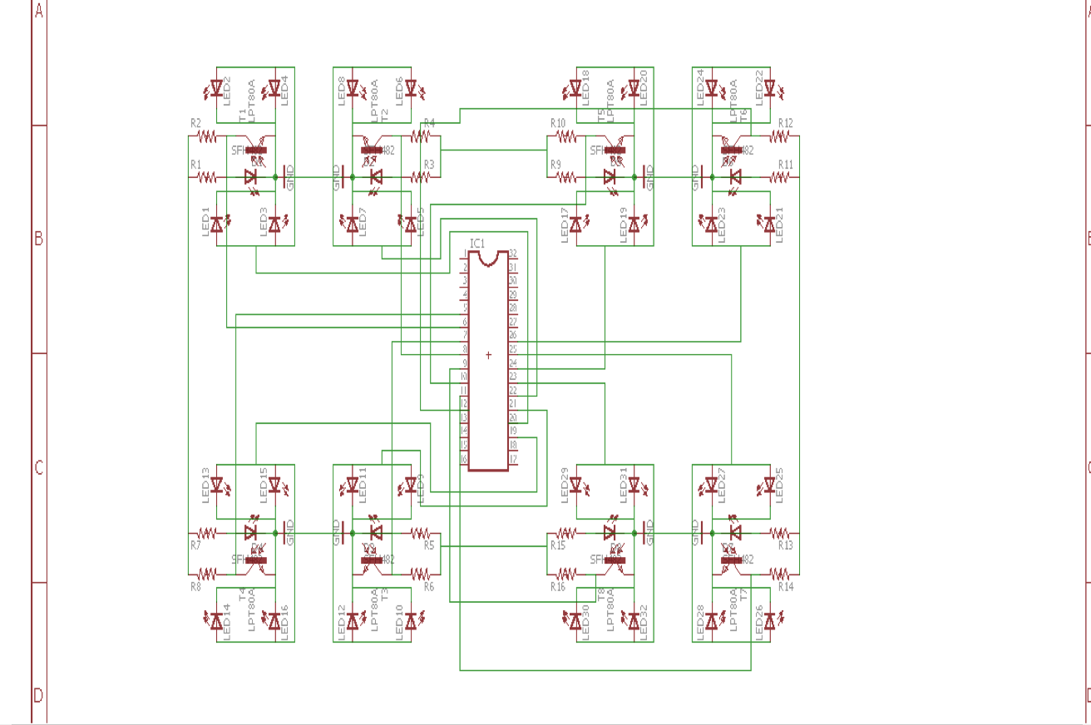

Fig. 01-Interface Schmatic of LED board

                                     -- Junyan Shi

**Appendix C:**

**Software Flowcharts**

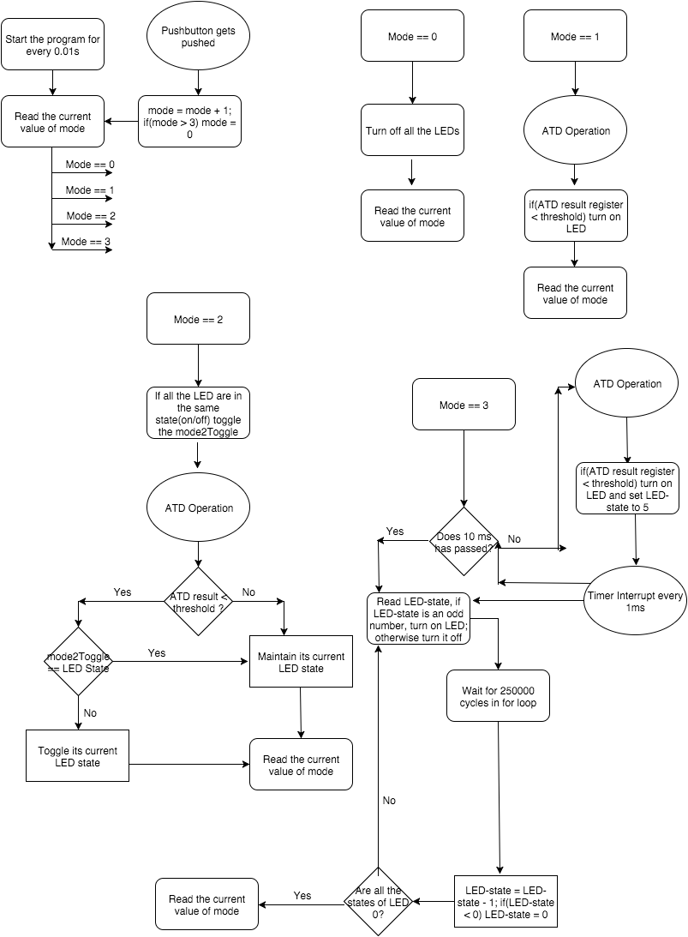

Fig. 01 Software Flowchar

--Documented by Xiaoyuan Zhang

**Appendix D:**

**Packaging Design**

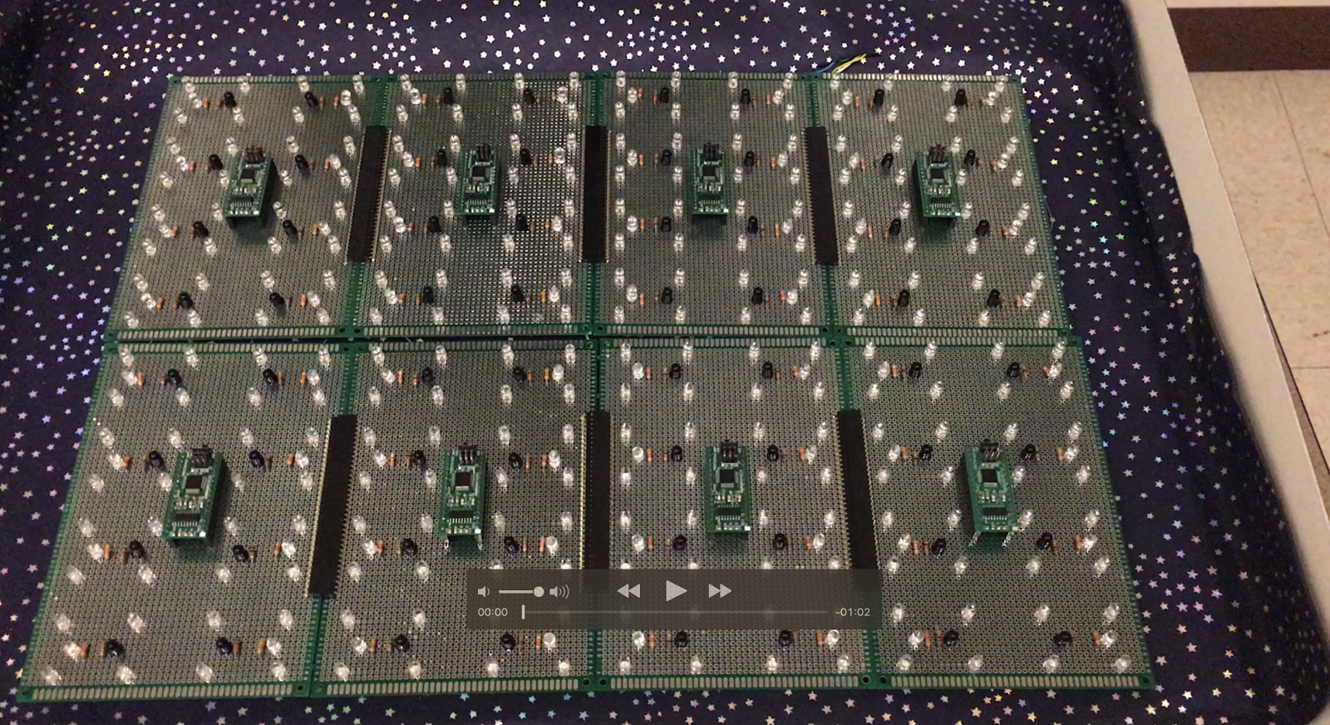

                         Figure 1 inside vision of final packaging

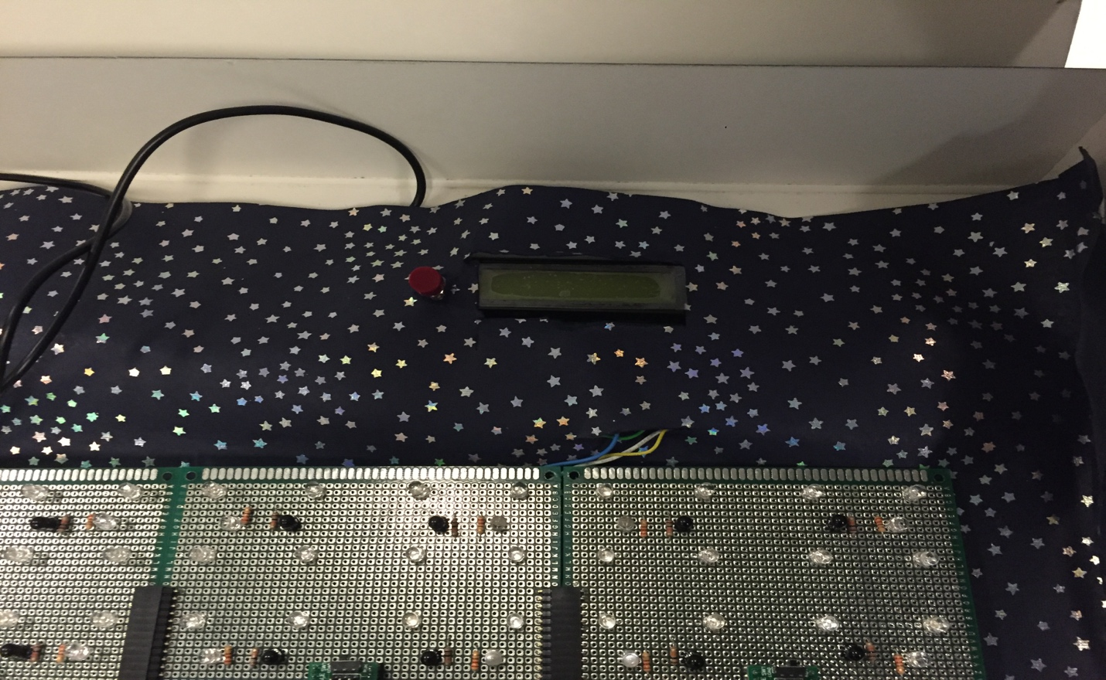

                               Figure 2   Zoom-in on LCD and pushbutton

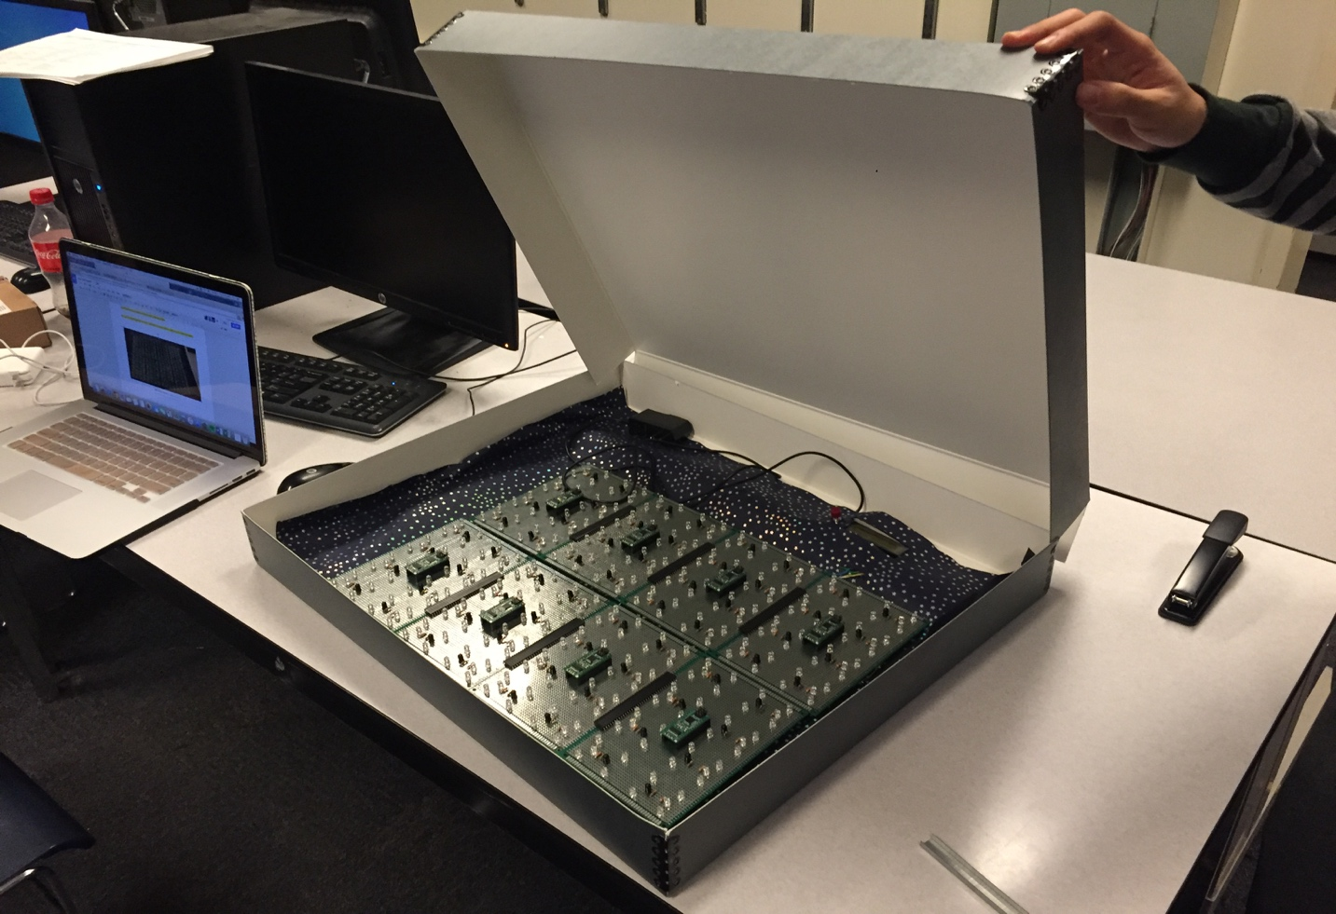

                                     Figure 3 Overall vision, including lid

                                                                                               Documented by Mengshi Feng

                                                                                  